Plasma characterisation for nonlinear wave-plasma interaction experiments
L. Selman¹, K. Wilson¹, P. MacInnes¹, C.G. Whyte¹, A.R. Young¹, A.D.R. Phelps¹, A.W. Cross¹, L. Zhang¹, B. Eliasson¹, D.C. Speirs¹, C.W. Robertson¹, K. Ronald¹, R.A. Cairns^{1,2}, R. Bingham^{1,3}, R. Bamford³, M.E. Koepke^{1,4}
¹ Department of Physics, SUPA, University of Strathclyde, Glasgow, G4 0NG, Scotland
² School of Mathematics and Statistics, University of St Andrews, KY16 9SS, Scotland
³STFC Rutherford Appleton Laboratory, Harwell, Oxford, Didcot, OX11 0QX, England
⁴Department of Physics, West Virginia University, Morgantown, WV 26506-6315, USA
Electromagnetic (EM) waves propagating in a plasma can non-linearly excite plasma oscillations, other EM waves and transfer energy to the plasma, especially at plasma resonances. Raman and Brillouin scattering, where two EM waves, coupled via a Langmuir or ion-acoustic wave respectively, are relevant to intense laser plasma interactions [1-4]. The Brillouin interaction can arise in plasma up to the critical density, whilst the faster growing Raman coupling arises and tends to dominate in plasma below quarter critical density. In magnetised plasma, beat-waves may couple to hybrid and cyclotron resonances of the electrons and ions. This may be useful in delivering energy in over-dense magnetically confined fusion plasma. Similar dynamics are known to arise in ionospheric experiments using powerful radio waves [5]. Microwave beams can be formed at normalised intensities comparable to those used for some laser plasma interactions, and can interact in tenuous, cool and accessible plasmas potentially enhancing diagnostic access and insight into the non-linear plasma dynamics.
In magnetised plasma, beat-waves may couple to hybrid and cyclotron resonances of the electrons and ions. This may be useful in delivering energy in over-dense magnetically confined fusion plasma. For example, in spherical aspect tokamaks, the high plasma density achieved for a given magnetic field means it is difficult to couple energy in at the lower harmonics of the electron cyclotron frequency where current drive is reasonably efficient. Coupling of two high frequency waves to both electron and ion cyclotron oscillations in the plasma and hybrid resonances offer a route to mitigate this difficulty [6,7]. This can also address problems in very dense fusion plasma where the evanescent gap between the antenna and the plasma makes it difficult to introduce lower frequency signals to directly modulate the ions.
Prior research into the phenomenon of Auroral Kilometric Radiation [8,9] has enabled the design and construction of a new cylindrical plasma experiment to investigate a range of multi-frequency microwave interactions in plasma. The final configuration of the planned apparatus is shown in Figure 1 along with a photograph of the apparatus as currently configured. Six magnet coils will generate an almost completely axial magnetic field having a high degree of uniformity, over a region 2m in length and 0.5m in diameter. The overall dimensions of the main vacuum envelope are 3m in length and 1m in diameter.
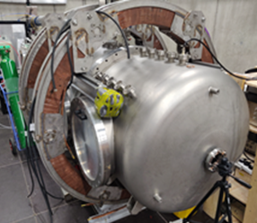
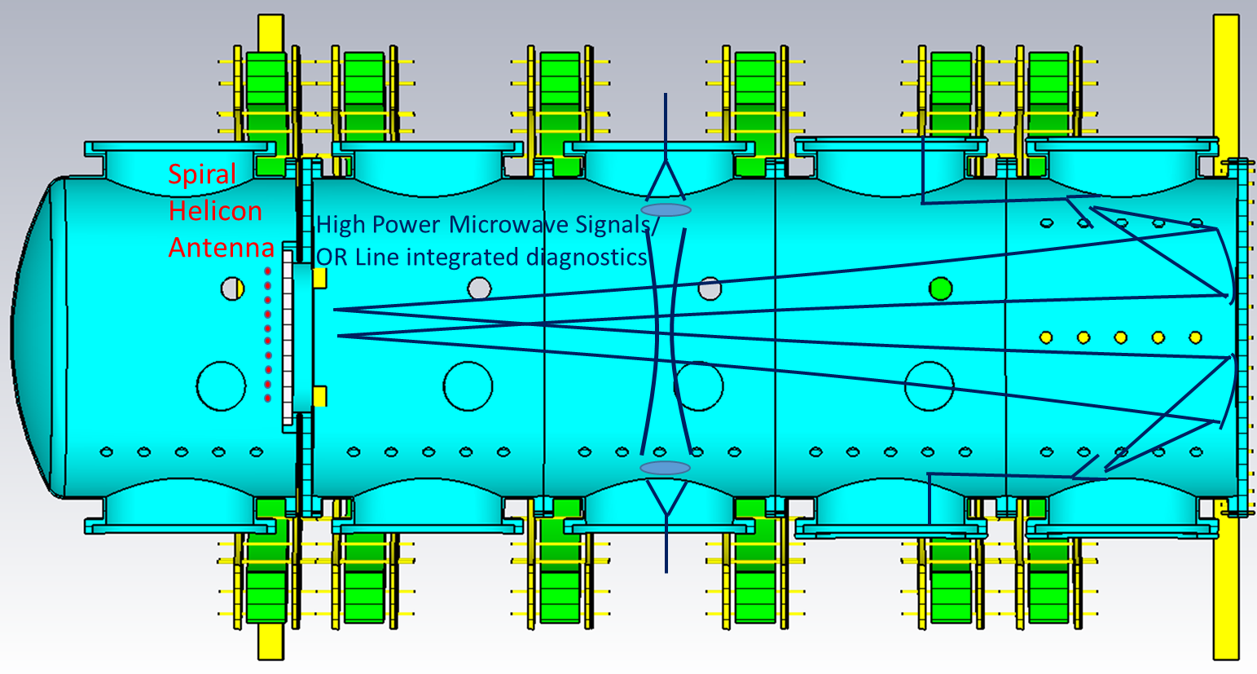
Figure 1: Illustrates the distribution of the ports and their alignment with the magnet coils and helicon antenna. Microwave beams may be directed both across and along the apparatus to study parametric scattering of O, X, R and L modes with plasma oscillations subject to differing degrees of magnetisation. Also shows an image of the experimental apparatus.
Using currents of up to 300 A, the magnitude of the magnetic field will be adjustable up to at least 0.085 T. At this field level it will be possible to operate the apparatus in a cyclotron resonant mode with 2.45 GHz microwave sources. The plasma will be excited by inductive coupling or a helicon wave launched from an antenna [10-12] of the flat-spiral ‘m = 0’ configuration through a borosilicate glass window. The antenna will be driven by a flexible 2-30 MHz RF source boosted by an amplifier to several kW average power and coupled via an RF matching network, with the antenna closed in a Faraday cage. Helicon systems of similar types have realised large volume 0.2-0.3 m³, dense (n_{e} up to 10¹⁹ m⁻³), cool T_{i} << T_{e} ~ eV plasmas with a potentially high ionisation fraction ~ 10%. In the first instance we seek plasmas in the density range 10¹⁵ m⁻³.
The apparatus will imminently be used in inductive mode with plasma frequencies around a few hundred MHz to study Raman and beat wave electron cyclotron coupling. Numerical simulations of both of these types of microwave interactions have been carried out using CST Particle Studio demonstrating the excitation of electrostatic waves. Simulation results are shown in Figure 2 for Raman scattering in a PiC simulation using two counter propagating EM beams with intensity approximately 5 kW/cm² at 9.22 GHz and 20 kW/cm² at 9.5 GHz in plasma with f_{pe} = 280 MHz, corresponding to n_{e} = 10¹⁵ m⁻³. After 30 ns elapsed time, strong electrostatic density fluctuations can be seen on the left hand side of Figure 2. The right hand plot shows the axial electric field associated with this density fluctuation. This strong coupling is observed when the frequency difference between the two waves is small (within 10%) of the plasma frequency.
Figure 2: PiC simulation of Raman scattering at 30 ns. On the left is the electron distribution. The right is the corresponding electric field caused by the beating input waves and the interaction with the plasma..
High power microwaves will be launched between a pair of horn antennae, which form a Gaussian beam, at ~ 9.5 GHz, into the plasma. The antennae have been fabricated and will be compared to numerical predictions. In the first instance the microwaves will be generated by compact magnetron oscillators (up to 25 kW) and tuneable TWT amplifiers (up to 7 kW). The amplifiers are tuneable to provide steady state signals in the range 9-10 GHz allowing the selection of single tones with frequency differences corresponding to plasma resonances. The amplifiers can equally be configured to develop a chirp over this bandwidth, or a transform-limited microwave pulse driven by an arbitrary waveform generator. Higher microwave power may be provided in the future and in the same spectral range with signals of ~ 1 MW from fast wave amplifiers. Short pulse and very high power research will be enabled by combining these amplifiers with dispersive pulse compressors to raise the peak power by up to a factor of 25. The apparatus is configured to allow launching of waves across the magnetic field in both the X and O modes, and along the magnetic field in the R and L modes to study the parametric scattering processes between modes subject to various degrees of magnetisation.
An inductively coupled plasma has been achieved at 14 MHz over a range of powers (5-200 W), pressures of 5x10⁻⁴-1x10⁻¹ mbar, in both helium and argon. Axial and radial scans of the 200 W inductively coupled mode in argon at 10⁻² mbar using an RF compensated Langmuir probe [13] have recently been completed. The results indicate n_{e} ~ 1.5×10¹⁵ m⁻³ with T_{e} < 1 eV at radial centre and approximately 30 cm from the RF antenna; this co-ordinate corresponds with the planned location for the initial microwave coupling experiments. The next step in commissioning the apparatus is operating with a bias magnetic field using two of the field coils in a Helmoltz pair to allow investigation of the helicon mode of operation. For the wave-plasma interaction and interferometry, a pair of horns have been fabricated to launch the Gaussian microwave beams. These have been bench tested and are in the process of being mounted.
The authors would like to thank the funders of the research, the UK EPSRC through grants EP/R004773/1, EP/R034737/1 and AFOSR through contract FA9550 18 7014.
[1] W. L. Kruer, ‘The Physics of Laser Plasma Interactions’, Westview Press, Boulder, Colorado, 2003
[2] D.W. Forslund et al., Phys. Fluids, 18, pp. 1002-1016, 1975
[3] W. L. Kruer, in ‘Laser Plasma Interactions 4’ Proc. 35th Scottish Univ. Summer School in Physics SUSSP35, 1988, ed. M.B. Hooper, Edinburgh University Press, imprint 1989
[4] J.F. Drake et al., Physics of Fluids, 17, pp. 778-785, 1974
[5] B. Eliasson et al., Nature Commun., 12, art. 6209, 2021.
[6] M.R. Amin and R.A. Cairns, Nucl. Fusion, 30, pp. 327-342, 1990
[7] M.R. Amin and R. A. Cairns, Phys. Fluids B, 3, pp. 151-158, 1991
[8] K. Ronald, D.C. Speirs, et al., 2008, Phys. Plasmas, 15, art.056503
[9] D.C. Speirs, R. Bingham, R.A. Cairns et al., 2014, Phys. Rev. Lett., 113, art 155002
[10] F.F. Chen, Plasma Sources Sci. Technol., 24, 014001, 2015
[11] E.E. Scime et al., Phys. Plasmas, 15, 058301, 2008
[12] S. Shinohara et al., Phys. Plasmas, 16, 057104, 2009
[13] I,.D. Sudit and F. F. Chen, Plasma Sources Sci. Technol., 3(162), 1994

